Semester 1 (Unit 3) Examination, 2017

Question/Answer Booklet

MATHEMATICS SPECIALIST

Section One: Calculator-free

Student Name/Number: ______________________________________________

Teacher Name: ______________________________________________

Time allowed for this section
Reading time before commencing work: five minutes
Working time for this section: fifty minutes

Materials required/recommended for this section
To be provided by the supervisor: This Question/Answer Booklet
Formula Sheet

To be provided by the candidate:
Standard items: pens (blue/black preferred), pencils (including coloured), sharpener,
correction fluid/tape, eraser, ruler, highlighters
Special items: nil

Important note to candidates
No other items may be taken into the examination room. It is your responsibility to ensure that you do not have any unauthorised notes or other items of a non-personal nature in the examination room. If you have any unauthorised material with you, hand it to the supervisor before reading any further.

Structure of this paper

Section | Number of questions available | Number of questions to be answered | Working time (minutes) | Marks available | Percentage of exam
Section One: Calculator-free | 7 | 7 | 50 | 52 | 35
Section Two: Calculator-assumed | 10 | 10 | 100 | 92 | 65
 |  |  |  |  | 100

Instructions to candidates

- The rules for the conduct of School exams are detailed in the _______________________________________School/College assessment policy. Sitting this examination implies that you agree to abide by these rules.

- Write your answers in this Question/Answer Booklet.

3. You must be careful to confine your responses to the specific questions asked and to follow any instructions that are specific to a particular question.

- Spare pages are included at the end of this booklet. They can be used for planning your responses and/or as additional space if required to continue an answer.
  - Planning: If you use the spare pages for planning, indicate this clearly at the top of the page.
  - Continuing an answer: If you need to use the space to continue an answer, indicate in the original answer space where the answer is continued, i.e. give the page number. Fill in the number of the question that you are continuing to answer at the top of the page.

- Show all working clearly. Your working should be in sufficient detail to allow your answers to be checked readily and for marks to be awarded for reasoning. Incorrect answers given without supporting reasoning cannot be allocated any marks. For any question or part question worth more than two marks, valid working or justification is required to receive full marks. If you repeat any question, ensure that you cancel the answer you do not wish to have marked.

- It is recommended that you do not use pencil, except in diagrams.

- The Formula Sheet is not to be handed in with your Question/Answer Booklet.

Section One: Calculator-free (52 Marks) Weighting 35%

This section has 7 questions. Answer all questions. Write your answers in the spaces provided.

Spare pages are included at the end of this booklet.

Suggested working time: 50 minutes.

Question 1 (9 marks)

(a) If , and , express each of the following in the form

(i) (1 mark)

(ii) (2 marks)

(iii) . (3 marks)

(b) On the diagram below, plot , and . (3 marks)

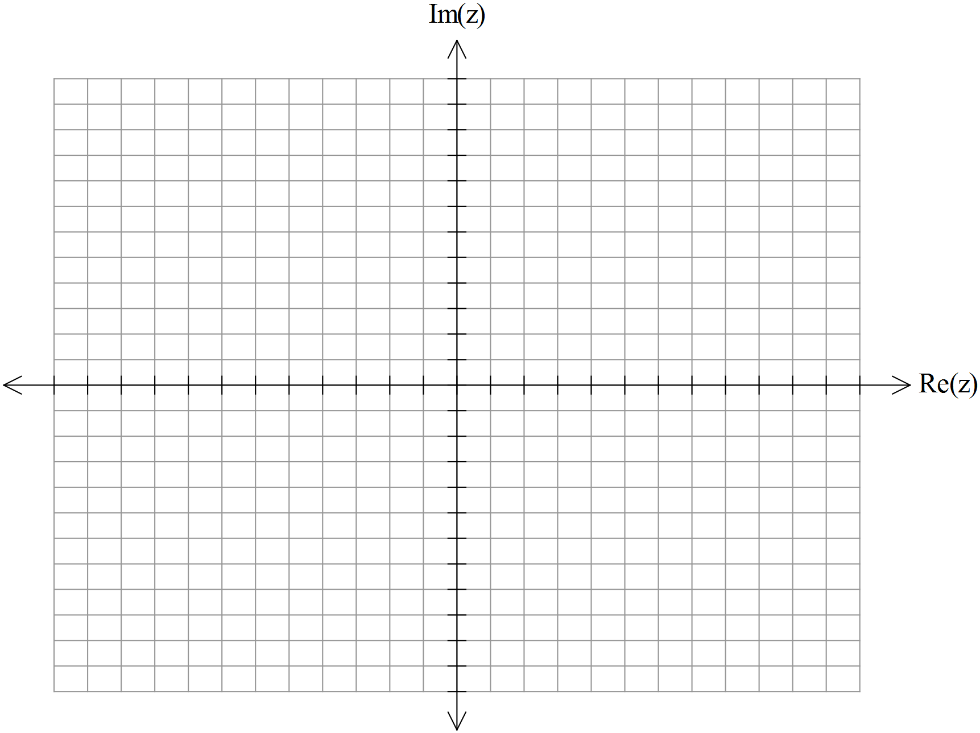

Question 2 (9 marks)

(a) Express in Cartesian form. (2 marks)

(b) Use de Moivre’s theorem to determine , expressing your answer in Cartesian form.
(3 marks)

(c) State a symbolic description for the set of points indicated by the shaded region on the graph drawn below. (4 marks)

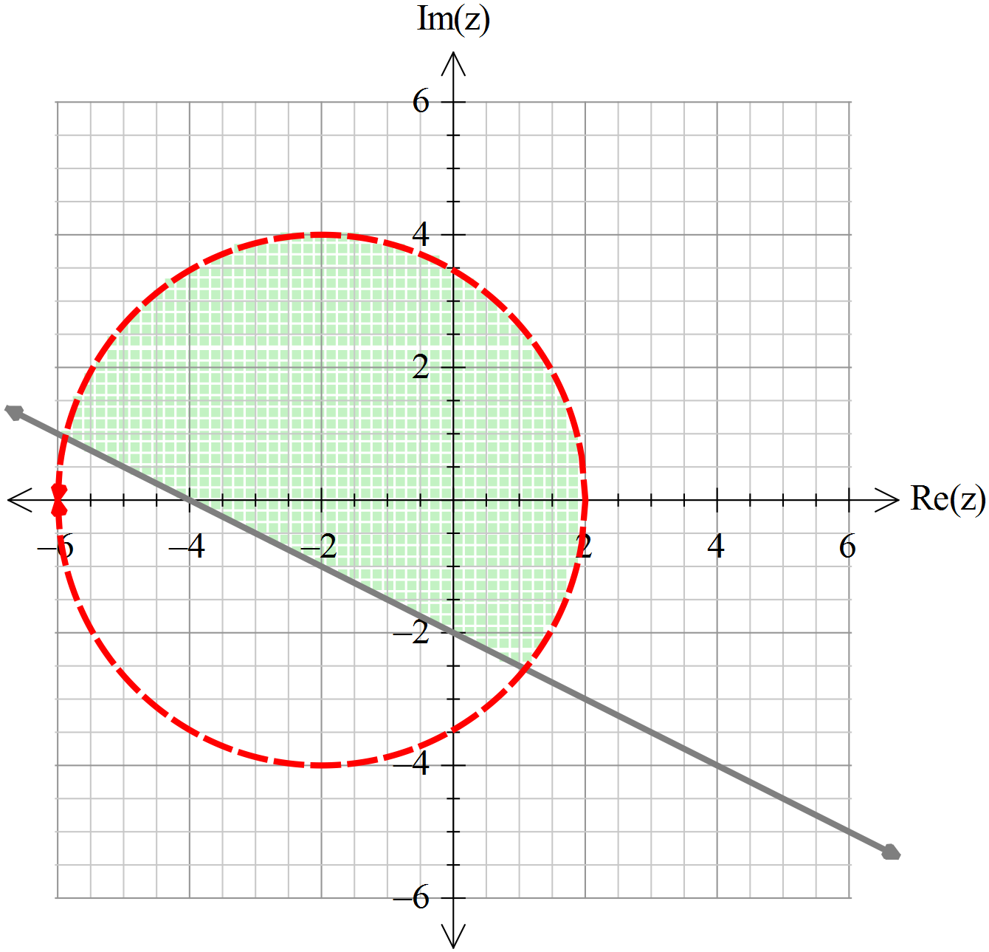
Question 3 (12 marks)

Functions and are defined as follows and .

(a) Determine an expression for and state its natural domain and range.
(3 marks)

(b) Determine an expression for and state its natural domain and range.
(3 marks)

Function is defined as .

(c) Determine the range of over its natural domain. (2 marks)

(d) The domain of is restricted so that is a function and this restricted domain contains . If this restricted domain represents the largest possible domain, determine the defining rule for .
(4 marks)

Question 4 (3 marks)

The graph of the function is shown on the axes below, where and are constants.

Determine the value of the constants given that and are known points on this graph.

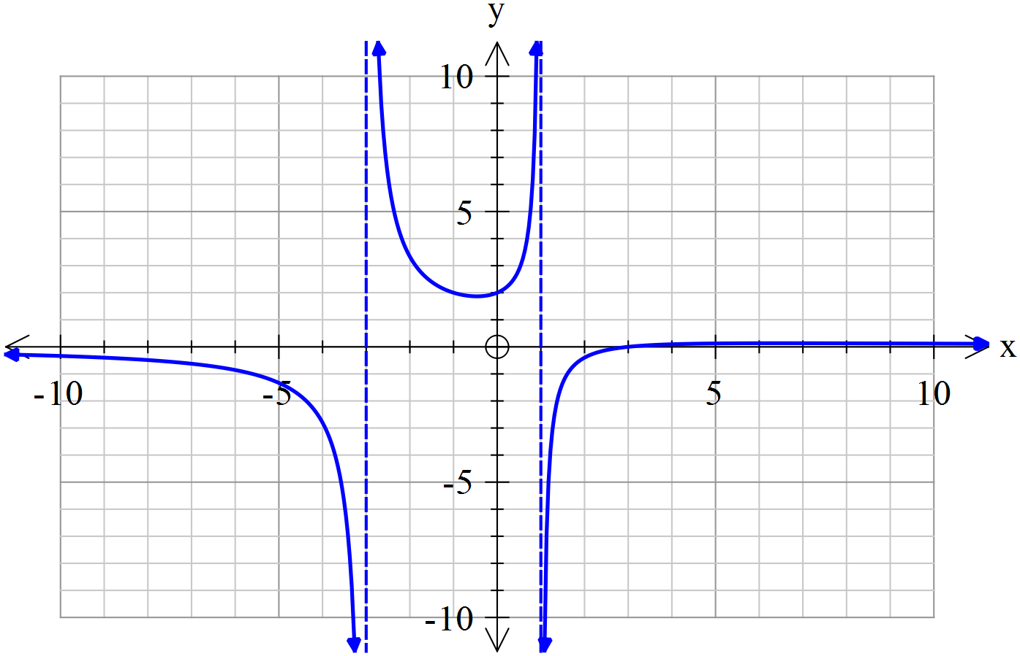

Question 5 (8 marks)

Consider the function as drawn below.
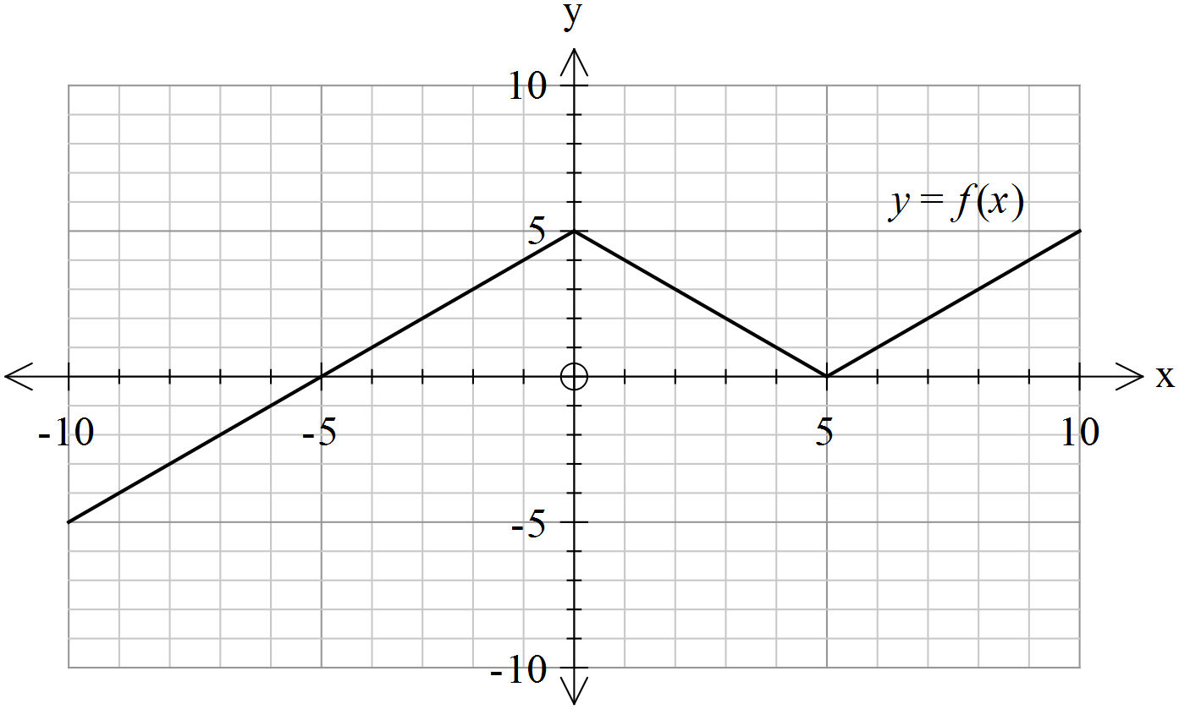

On the axes below, sketch the following:

(a) (2 marks)
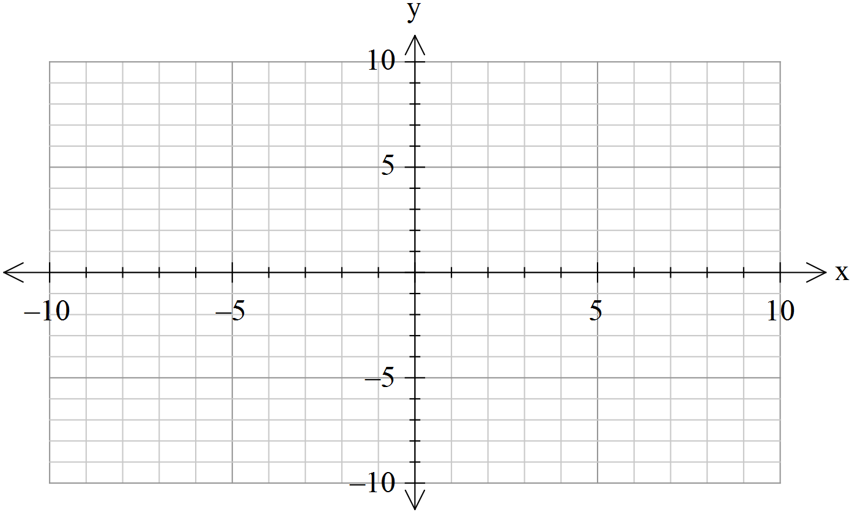

(b) (2 marks)


(c) (4 marks)



Question 6 (5 marks)

Consider the function with which is drawn on the axes below.

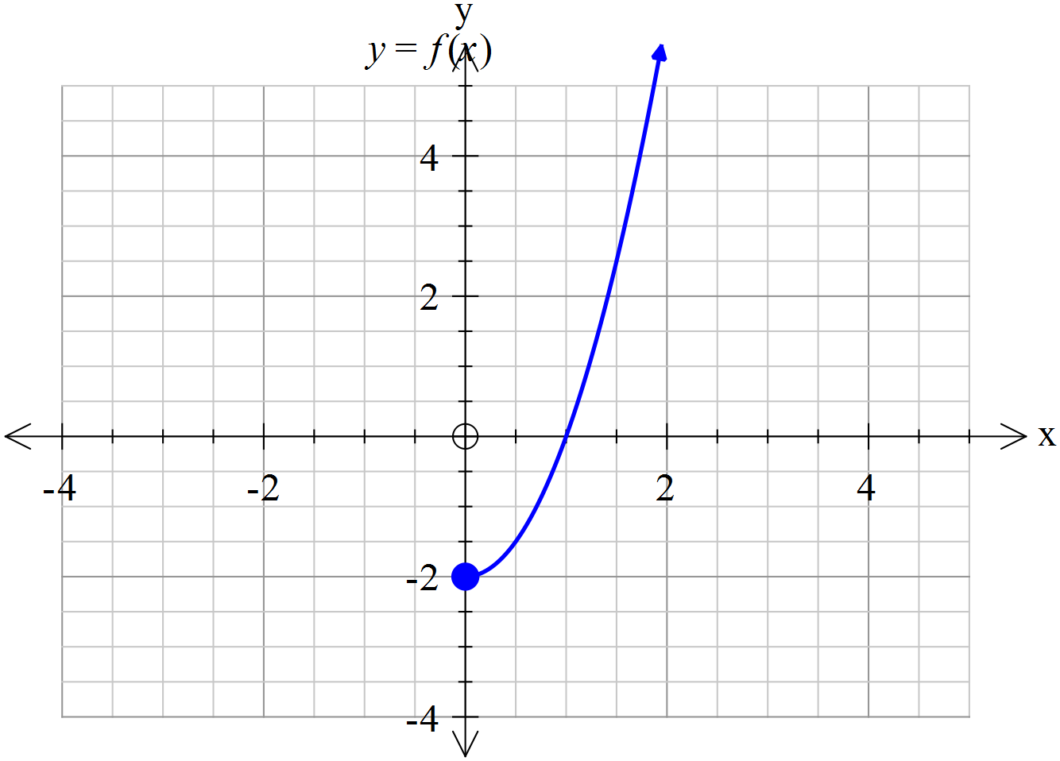

(a) On the axes above, sketch . (3 marks)

(b) Solve . (2 marks)

Question 7 (6 marks)
(a) Solve the following system of linear equations: (3 marks)
$$\begin{matrix}x+3y-2z & = & 3 \\ 4x+14y-3z & = & 19 \\ 3x+12y+2z & = & 21\end{matrix}$$

(b) Consider the following system of equations: (3 marks)
$$\begin{matrix}x+3y-2z & = & 3 \\ 4x+14y-3z & = & 19 \\ 3x+12y+az & = & b\end{matrix}$$

For which values of the constants $a$ and $b$ are there infinitely many solutions?

Additional working space
Question number: __________________

Acknowledgements

© MAWA, 2017
This examination is Copyright but may be freely used within the school that purchases this license.
- The items that are contained in this examination are to be used solely in the school for which they are purchased.
- They are not to be shared in any manner with a school which has not purchased their own license.
- The items and the solutions/marking keys are to be kept confidentially and not copied or made available to anyone who is not a teacher at the school. Teachers may give feedback to students in the form of showing them how the work is marked but students are not to retain a copy of the paper or the marking key until the agreed release date stipulated in the purchasing agreement/license.
Published by The Mathematical Association of WA
12 Cobbler Place, MIRRABOOKA 6061.

